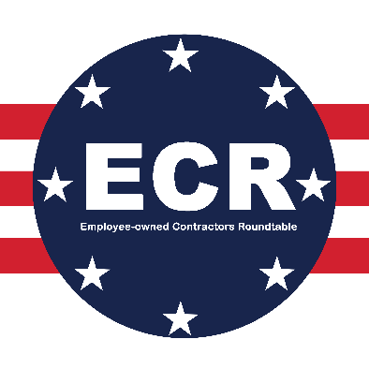

Employee-owned Contractor Roundtable (ECR)
Membership Talking Points 2022
For Current ECR Members

ECR’s Mission and Value Statement
The Employee-Owned Contractor Roundtable (ECR) is a coalition of federal government contractors that are organized as private subchapter S corporations wholly-owned through an employee stock ownership plan (ESOP). The Employee-Owned Contractors Roundtable is committed to policy solutions that modernize contracting practices that align with federal government goals of increasing employee ownership. ECR Values are as follows:
- All small businesses need to thrive and have a pathway to growth and studies demonstrate the 100% ESOP structure is the best pathway to that growth.
- Creating and sustaining employee ownership is in the interest of businesses, workers, the American economy, and the federal government.
- Strengthening the U.S. industrial base to encourage growth and prevent stagnation among small businesses
- Creating and protecting retirement value for employee-owners while giving 100% ESOPs a pathway to growth.

Why an ESOP Federal Contractor Should Join ECR
- ECR is the premier coalition for ESOP businesses that are primarily federal contractors with a membership of ESOP businesses that are either, or intend to become, 100% employee-owned.
- ECR members are active participants in developing innovative government procurement policies that incent the creation of new ESOPs, sustain current ESOPs, and strengthen the national industry base by harnessing the benefits of employee ownership.
- ECR provides a forum for members to interact with like-minded leaders of similarly situated ESOP businesses that are also federal contractors.
- Additional ECR members provide the needed resources (membership dues) and political coverage (office/job locations, employee-owners) to advance ECR efforts, specifically by:
  - Funding studies and data research that speak to our issues and reinforce our messages;
  - Supporting the hiring of technical experts;
  - Increasing our political coverage in Congress, connecting more ECR employee-owners with key Members of Congress;
  - Extending touchpoints within the Department of Defense (and other agencies) so that ECR efforts like the 100% ESOP sole-source follow-on pilot program that was passed as part of the FY23 NDAA are implemented as Congress intended.

ECR Executive Council Level ($25,000/year)
- At the Executive Council level ($25,000/year) you are AT THE TABLE having a say in the policy direction, growth, and vision of ECR.
- The Executive Council provides you with regular interactions with C-Suite executives of other ECR member companies, gives you a voice in developing the policy scope of ECR engagement, and provides regular interactions with Members of Congress and Agency staff to advocate for ECR’s policy objectives.
- You have regular access to ECR staff and receive timely industry, political, and federal policy intel.
- The Executive Council meets quarterly (ideally in person) to review ECR activity, plan for future efforts, and assess progress on key priorities.

ECR Supporter Level ($10,000/year)
- ECR has launched a new membership level for companies that wish to be part of ECR, but don’t have the time, resources, and/or portfolio of government work to warrant joining at the Executive Council level.
- The Supporter Level is vital to ECR’s grassroots engagement and overall success by broadening ERC’s political footprint and touchpoints with DoD (and other federal agencies).
- Supporter Level members will receive regular ECR updates via monthly calls, be asked to attend an annual lobby day, support ECR advocacy activities, and coordinate with ECR on the 100% ESOP follow-on sole-source pilot program implementation.
- This level is not available for any company over 1,000 employee-owners.

Ready To Join?
- Contact Matt Pearce (mpearce@vennstrategies.com/701-471-8391) or Matt Scott (mscott@vennstrategies.com/(516) 382-3613).
- Process for joining:
  - You will be asked to fill out an ECR membership application that collects information on company size, the scope of federal contracting work, employee-owner headcount, office locations, etc.
  - Once completed, email the form back to either Matt, and it will be submitted for approval to the ECR Executive Council.
  - If approved, you will receive an onboarding email and will be officially welcomed to ECR.

